Memory Segmentation in 8086 Microprocessor
Segmentation involves logically dividing the computer’s main memory into distinct segments, each with its own base address. This technique aims to optimize the speed of computer system execution, enabling the processor to efficiently retrieve and process data from memory. In the context of the Memory Segmentation in 8086 Microprocessor, is a mechanism used to manage and organize the memory space. The 8086 microprocessor employs a segmented memory model, where the entire 1 MB memory space is divided into segments, and each segment is 64 KB in size. The combination of a segment and an offset within that segment forms a physical address.
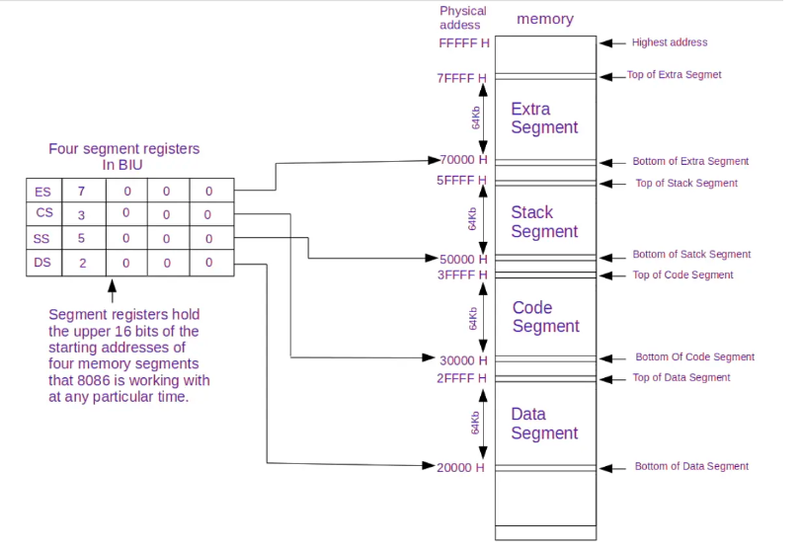

Memory Segmentation: A 16-Bit Odyssey
The 8086 microprocessor, despite its groundbreaking capabilities, faces a significant limitation with only 16 address lines. This means it can directly access a mere 64 KB (2^16) of memory, a pittance in the expansive landscape of computing requirements. Enter Memory Segmentation, a technique devised to overcome this limitation by dividing the physical memory space into smaller, logical segments.
Memory Segmentation: Registers and Selectors
To comprehend Memory Segmentation, one must acquaint themselves with its integral components:
- Segment Registers: The 8086 boasts four segment registers—CS (Code Segment), DS (Data Segment), SS (Stack Segment), and ES (Extra Segment). Each register holds the starting address of a specific segment.
- Segment Length: The size of each segment is determined by a 16-bit Limit Register, setting the boundaries for effective segmentation.
- Segment Selector: An indispensable aspect of the process, the 16-bit segment selector acts as an index into a descriptor table. This table, in turn, stores crucial information like the base address and size of the segment.
Advantages of the Segmentation
Memory Segmentation is not just a theoretical construct; it brings tangible benefits to the table:
- Overcoming the 64 KB Barrier: The primary objective of Memory Segmentation is to extend the 8086’s reach beyond the 64 KB address limit, allowing it to access more extensive memory resources.
- Enhanced Memory Protection: Through segmentation, different segments can be assigned varying access rights—read, write, execute—creating a fortress around code and data, safeguarding them from unauthorized access.
- Streamlined Memory Management: Switching between segments becomes a breeze for programs, eliminating the need to laboriously load new base addresses into registers.
Disadvantages of the Segmentation
As students preparing for exams, it’s crucial to recognize the drawbacks of Memory Segmentation:
- Increased Complexity: The implementation of Memory Segmentation introduces additional overhead to the processor’s instruction execution cycle. Navigating this complexity demands a solid understanding of the underlying mechanisms.
- Inefficient Memory Utilization: While segmentation offers flexibility, choosing segment sizes requires careful consideration to prevent unnecessary wastage of precious memory space—a challenge that demands both skill and precision.
- Compatibility Quagmire: Programs originally designed for non-segmented architectures may face compatibility issues when transposed into a segmented environment. This necessitates meticulous modifications to ensure seamless functionality.

